ZRT-1300-G6 Six-axis Automatic Cutting Machine
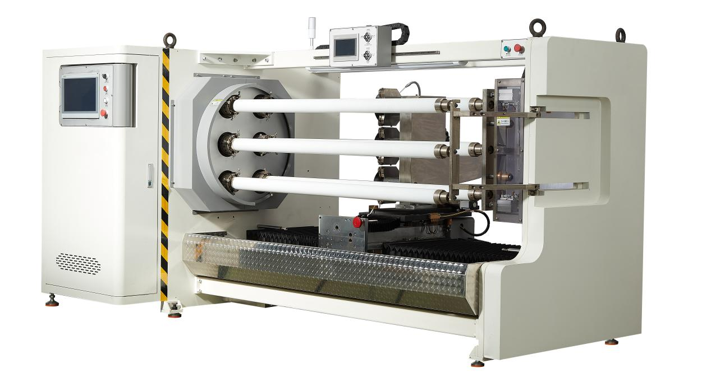

Equipment layout：
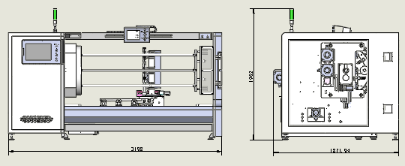
Basic Use：
It is mainly used for slitting of electrician's tape, electronic film, grid tape, PE, TPU, PET, kraft paper, paper tape, BOPP, adhesive tape, and acrylic, double-sided tape, masking tape, etc.
Equipment Advantages：
- The HECO motion control system features 12 modes for cutting products of different widths, allowing free selection from the starting row to the ending row. It also offers three different feed speeds for slitting products.
- The main shaft is controlled by 5000W servo, and the circular cutter is controlled by 3300W servo. The advantages are: the machine will stop immediately upon an alarm to prevent the cutter from breaking.
- The horizontal movement is achieved using an NSK 3210 lead screw and 30 guide rails, with 1500W servo control. This ensures a positional accuracy within 1000mm with a tolerance of ±0.02.
- The feed mechanism adopts an upper silver 3210 screw and 30 guide rails, with 1500W servo control, ensuring the strength and accuracy of the feed.
- The swing angle is equipped with an upper silver 1610 screw rod and 400W servo control. The maximum angle is +9.5° and the minimum angle is -9.5°.
- The cooling process uses a 60W water pump, and the precise ball valve is used to regulate the water volume, achieving silent cooling.
- The tool rest and the transverse movement processing are treated with QBQ to enhance the hardness, wear resistance, corrosion resistance and deformation resistance of the parts.
- Dual screens are adopted: The main screen is a 15-inch display, and the auxiliary screen is a 7-inch one. The operation is simple and clear.
- Overall machine lighting: Lighting for opening the electrical box, photos of opening the machine box, and lighting for the startup operation.
- The knife box is designed as a stainless steel dry-wet separation type. The cutting silicone oil is absorbed by a sponge in the wet area, and the dry area is wiped clean with wool felt to dry the blade. This reduces the residue of silicone oil on the material.
- Drainage system: Designed with stainless steel diversion pipes for drainage, so there will be no silicone oil everywhere during operation.
- Reversal structure: Utilizing a heavy-duty divider with a 1000w servo motor for the flipping operation, ensuring zero error in the flipping process.
- The three axes are simultaneously segmented, and the idle axes can be used for unloading and loading operations, thus saving time and improving work efficiency.
- Tool rest: Can be pre-assembled: Pneumatic and servo electric cylinders, suitable for products with a main shaft core below 25mm.
Main Technical Parameters：
Name/Model | ZRT-1300-G6
paper core | Customized according to customer requirements (can be freely replaced)  25/32/38/50/76=6strips
Cutting width | 0.5-1300mm
Maximum cutting diameter | 180mm（The material thickness is 50mm, and the maximum diameter of the main shaft varies.）
The maximum diameter of the shearing blade | 200mm
Dual-screen control | 15inches 7inches
power supply | 380V（Customizable 220V） 50/60HZ/15KW
air pressure | 5KG
Machine size | L3200mm*W2000mm*H2000mm
Net Weight | 3.5T
Configuration Parameters：
Model | SCT-1300-G6
Main touch screen | 15 HCFA
Auxiliary touch screen | 7inches HCFA
Rack wall panel | Thickness: 40mm
Motion controller | HCFA
Spindle servo motor | 5000W HCFA
Spindle servo driver | 5000W HCFA
Circular knife servo motor | 3000W HCFA
Circular knife drive | 3000W HCFA
Lateral servo motor | 1500W HCFA
Lateral servo driver | 1500W HCFA
Feed servo motor | 1500W HCFA
Feed servo drive | 1500W HCFA
Angle positioning servo | 400W HCFA
Angle positioning servo drive | 400W HCFA
Rolling servo | 1000w HCFA
Rolling servo driver | 1000w HCFA
Water pump | 60W
Planetary reducer | Smetre
Slicer | JU JIU
Air switch | chint
Switching power supply | Mingwei
Photoelectric sensor | BOJKE
Proximity switch | Yangming
AC contactor | Schneider
Relay | IDEA
Button switch | Schneider
Three-color warning light | TAYB
illumination | LED
Feed screw | HIWIN 3210
Horizontal moving screw rod | HIWIN 3210
Adjustable angle screw rod | HIWIN 1510
Cutting-in guide rail | HIWIN30
Lateral guide rail | HIWIN30
Operation box guide rail | HIWIN15
Solenoid valve | Asicko
Air cylinder | AIRTAC
Linear rail | HIWIN
Magnet switch | AIRTAC
Spindle 3 inches (6 pieces) | DC53
Bearing | NSK
Fuselage | Lmported paint finish
Round knife (single-sided / double-sided / imported high-speed steel) (single-sided / double-sided / tungsten steel) | 3 pieces (size determined by the material) - maximum 200mm
Work-box | 1 set
Dialgage | 1 set
The tool post | 1PCS
PE pipe | 6 items

